**I. Introduction**

This document has the information regarding the test procedures and test plan for the system to be made for Arandia College Registration and its Grading System. The test information or methods in this document supported throughout the system’s testing phase.

1. **Goals and Objectives**

* The system shall resolve all the inconsistencies and redundancies that Arandia College Registration and Grading System may encounter. It will be of help to the school with regards to organizing their data resolving issues and problems in handling database management. It provides a timely and effective data management system to clients and offer cost efficient solutions for database management.
* The project is for the teachers and students’ convenience where the teachers can input the grades of the students online to lessen some paper works like creating form 137 card. The students can view their grades online after their teachers have submitted their grades they don’t have to go to school to get their form 137 card. Although the students/parents can demand the teacher for a form 137 card if they want to get a hard copy of the students’ grades.

1. **Statement of Scope**

The Arandia Grading System will be managed by the school’s IT Department. The main functionality of the system is to automate the way of distributing grades of the students and teacher’s online submission of grades. This system can be accessible outside the organization.

1. **Major Constraints if any**

A simple and user-friendly design that a user can access easily. We have designed it with the knowledge that any people could understand. We have considered some not computer literate parents and designed it with ease that they can access their children’s record without any hardships. What you see is what the actual used for it.

**d. Roles and Responsibilities**

|  |  |
| --- | --- |
| **Deliverables** | **Performed by** |
| **Test Plan** | Project Team |
| **Test Cases** | QA Team, Client |
| **Test Report** | QA Team |
| **Client Feedback Report** | Project Team |

**e. Test Schedule**

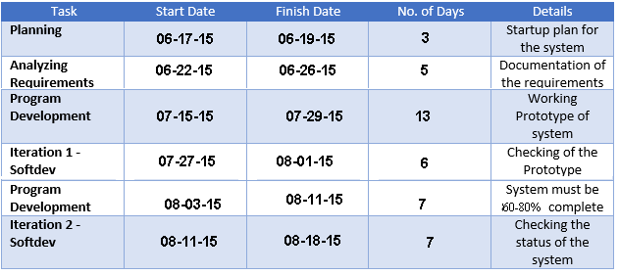

**II. Test Plan**

1. **Software/Application/Website to be tested**

* Framework
  + Yii 2.0
* Programming Language
  + PHP
  + HTML
  + CSS
  + JavaScript
* Database Server
  + PHPMyAdmin
* Web Server
  + XAMPP
* Repository and Development
  + Tortoise SVN
  + Tortoise Git
  + Sublime Text
* For System Testing
  + Google Chrome
  + Mozilla Firefox

1. **Testing Strategy**

|  |  |
| --- | --- |
| **Unit Testing** | * To be done by the project team * Try to Login * Try to register account * Try to add and edit records then see if records are updated |
| **Integration Testing** | * To be done by the project team * The whole system will be checked * To be done in development phase |

**III. Test procedure (Test Case)**

**Administrator**

|  |  |  |  |
| --- | --- | --- | --- |
| **TC ID** | **Step Description** | **Expected Result** | **Possible Error** |
| **1** | Logs as admin | * Redirect to admin homepage | * Forgot password or username * Typographical error of username or password. |
| **2** | Record grades of student | * Teacher will input the grades of the student * System will save the recorded grades of the student | * Cannot find the record of the student * Enters grade to the wrong student. |
| **3** | Admin monitors student grades | * System will direct the admin to the student lists page | * Network interruption |
| **4** | Validate student grade | * Teacher will verify the student grade * System will direct the admin to the updated student lists page | * Unable to modify student record. * Unable to display and view student record. |

**Parent**

|  |  |  |  |
| --- | --- | --- | --- |
| **TC ID** | **Step Description** | **Expected Result** | **Possible Error** |
| **1** | Log in as regular user | * Redirect to user homepage | * Forgot password or username * Typographical error of username or password. |
| **2** | Parent wants to see his/her child’s grade | * System will direct the user to the student grade’s page | * No internet access * Unable to display student’s record |
| **3** | Parent wants to see the class standing or student status | * System will direct and display the student class standing page | * No internet access * Unable to display page |

**Student**

|  |  |  |  |
| --- | --- | --- | --- |
| **TC ID** | **Step Description** | **Expected Result** | **Possible Error** |
| **1** | Login as regular user | * Redirect to user homepage | * Forgot password or username * Typographical error of username or password. |
| **2** | Student wants to know his/her class standing | * System will direct and display the student class standing page | * No internet access * Unable to display page |
| **3** | Student wants to know his/her grades | * System will direct the user to the student grade’s page | * No internet access * Unable to display student’s record |

**IV. Risk and Contingencies**

**Risks:**

* The client might not meet the hardware and software requirements.
* Error of web pages and some functionalities.
* No proper training.

**Actions to be taken:**

* Upgrading the client’s hardware and software.
* The system should pass the quality assurance test.
* Conduct user training.

**V. Conclusions and Recommendation**

Both the school and the students/parents can benefit from the web-based system. It can be convenient to the teacher to give grades and also for the parents/students to view their grades.